Chapter 13, Problem 50.

Calculate the input impedance for the network in Fig. 13.114 below.

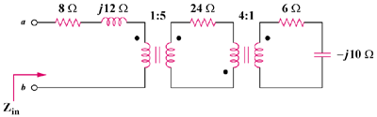

Figure 13.114
For Prob. 13.50.

